Ideation Phase-II
Define the Problem Statements
Date | 21 September 2026
Team ID | SWTID-2026-6039
Project Name | AI WeatherWise API
Maximum Marks | 2 Marks

Customer Problem Statement Template:
Create a problem statement to understand your customer’s point of view. The Customer Problem Statement template helps you focus on what matters to create experiences people will love.
A well-articulated customer problem statement allows you and your team to find the ideal solution for the challenges your customers face. Throughout the process, you’ll also be able to empathize with your customers, which helps you better understand how they perceive your product or service.
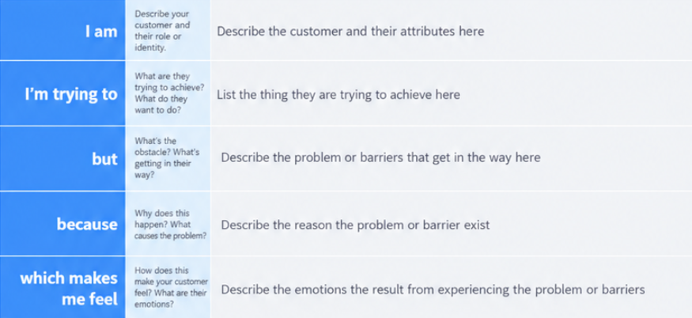
Example:
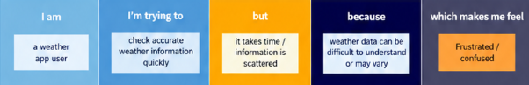
Problem Satement(PS) | I am (Customer) | I’m trying to | But | Because | Which makes me feel
PS-1 | A weather app user | Check accurate weather details | Weather information is unclear or scattered | Different sources show different information | confused
PS-2 | A daily traveler | Know upcoming rain and temperature | Weather updates are not timely | I may not receive location-based alerts | unprepared

